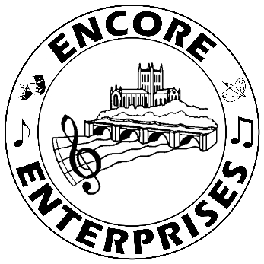
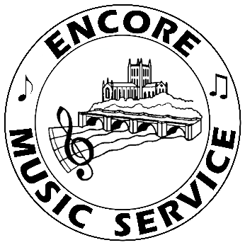
KS2 Home Learning Music Activities
Summer Term - Week 10

HELLO MUSIC MAESTROS! Welcome to another fabulous week of MUSIC 😊

Years 3 and 4
Listening
Most colleges in America have marching bands. This one goes beyond marching with a vibrant performance that you will want to clap along with. While you are having fun watching this, see how many instruments you can spot and name.

American College Band: Uptown Funk https://www.youtube.com/watch?v=bqIqr97lVHo

Which family of instruments can’t you see? What is that really large brass instrument with a huge bell? Which instrument plays an amazing solo? What do the musicians do that makes their performance extra exciting?

Maths and Music
Here is a very different version of uptown funk. This might help you remember your three times table! https://www.youtube.com/watch?v=9XzfQUXqiYY

Choose one of your favourite songs and change the words to help you learn a different times table. How about a trickier table like the sevens or eights?

Music Theory
We often hear people talking about “the beat” in music but what do they mean? Watch this video and join in with Luigi and Mike (and their special guest) as they sing and dance their way through explaining why the beat is the heart of the music
https://www.youtube.com/watch?v=0kaX2l413p8

We have all seen music written down but how much do we know about what those funny signs and symbols mean? Watch the video and follow the patterns to learn about reading rhythms. Clap along with the rhythms, saying the rhythm names as well. https://www.youtube.com/watch?v=4vZ5mlfZlgk

For those of you that are confident with reading rhythms, have a go at making a rhythm quiz. Copy the notes that you see on the video onto pieces of paper or card. They might look a bit like this.

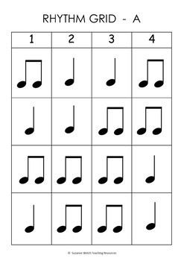

Make a few of each different sort of rhythm. Hold them face down and shuffle them like a pack of cards. Turn over and place them face up in a row. Clap the rhythm.

Singing
This song has some really strong rhythms and great use of dynamics (loud and soft bits). Lots of you may have sung it in assembly at school.
https://www.youtube.com/watch?v=FOsX3VZrfL4

As an extra challenge, have a go at some of these lovely science and art activities linked to this song.
https://www.outoftheark.co.uk/ext/pdfs/outoftheark-at-home/SongActivity-LIVING-AND-LEARNING.pdf

‘The School Rules Song’ This is a fun song that reminds us of how we should behave in school. Lots of you might know this already but it’s really fun. We like the fact the song gets faster as it goes through.
Here is a link to a clip of this song for you to sing along with.
https://www.youtube.com/watch?v=9wTl3Sx156k

If your school has an account with Out of the Ark, you could ask them to share the whole song with you.

Quiz
We all love a quiz! Guess the name of these Disney tunes. You could split into teams. Add up your scores to see who wins. Have fun! https://www.youtube.com/watch?v=06t_JP0AbZI&t=87s

Years 5 and 6

Listening
Most colleges in America have marching bands. Disneyland’s All-American College Band goes beyond marching to incorporate some fantastic rhythmic moves to reflect the mood of the different sections of the music. Can you name all the instruments in this clip? Can you spot any players who are doubling (when they play more than one instrument and switch between them)?

American College Band: Star Wars https://www.youtube.com/watch?v=dGyFrEcPYlI

The Star Wars music has different sections or movements. Which is your favourite? Describe the mood of the music; is the music trying to tell a story? Think about how the composer uses pitch, tempo, dynamics, rhythm and so on.

Now choose a contrasting section. How is the music different from your favourite part? How many reasons can you think of?

Quiz
We all love a quiz! Guess the movies these theme songs belong to. You could split this into a couple of sections as it is quite a long quiz. Enjoy!
https://www.youtube.com/watch?v=HI49yUqcMH0

Music Theory
You will probably have seen a musical stave (known as a staff in America). Here are two videos for you to watch and join in with to help you learn about the lines and spaces on a stave:

After watching this video, you’ll soon remember the names of the music notes.

- Lines and spaces, baby! https://www.youtube.com/watch?v=2lXF-AcYbv0

- Try this note name quiz to see how well you have learnt the note names
https://www.classicsforkids.com/games/note_names.php

There are several elements of music. Musical experts have differing opinions about just how many elements there are. But they all agree that dynamics is one of them. Watch this video to learn just what a difference dynamics make to the music we play and listen to.

- Elements of music: Dynamics https://www.youtube.com/watch?v=f96k2siTTpA

Song
This is a song called ‘Just Sing!’. Could you add some actions or dance moves to match this happy tune? https://www.youtube.com/watch?v=ut5_ZaEAS3s

