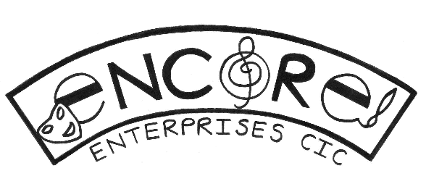
Music Resources for Learning at Home – KS 2
Year 3:
Listening - Here is a clip of George meeting all the sections of the orchestra. Which instrument would you most like to play? https://www.youtube.com/watch?v=M0Jc4sP0BEE

Activity - https://www.youtube.com/watch?v=388Q44ReOWE Can you feel in your head how long you need to freeze for?

Singing – Have a go at this warm up. Make sure you are pulling all the funny faces…
https://www.youtube.com/watch?v=K5ibRYDBFTw&fbclid=IwAR3Vjoh4UyyNuwfhcnDnnZ2FjC81_NFkHTb05N4wepJ_euHFtUfmP3IjS2Y
Here is a song for you to learn. It’s called “Good to be Me”. Watch the video then have a go at singing. First of all join in with the words: “1 2 3, good to be me, 1 2 3.” Can you join with that each time it comes?
Next include the words, “1 2 3, it’s good to be me and I want the world to know it’s good to be me!”
Finally, sing all the words including the last part, “I’m a special person and there’s only one of me, and no-one else is prouder of the person who is me!”
You could have a go at putting in the signing too!

Year 4:
Listening – Listen to this piece of music by Sam Kelly and the Lost Boys.
https://www.youtube.com/watch?v=z2l64IFQKzQ
Can you identify the instruments you can hear? Can you spot any times when one or more instrument stops playing?
Activity - Now have a look at this version of the song to see if you were right. https://www.youtube.com/watch?v=dFMS3RgBz9Q
Singing - Have a go at this warm up. Make sure you are pulling all the funny faces…
https://www.youtube.com/watch?v=K5ibRYDBFTw&fbclid=IwAR3Vjoh4UyyNuwfhcnDnnZ2FjC81_NFkHTb05N4wepJ_euHFtUfmP3IjS2Y
Here is a song called Just Like a Roman. Have a listen then have a go at singing the echo in the chorus,
Gonna tell you how to (Part 1) Eat like a Roman, (Part 2, echo) Eat like a Roman,
(Part 1) Drink like a Roman, (Part 2, echo) Drink like a Roman,
(Part 1) Dress like a Roman, (Part 2, echo)
Dress like a Roman, (Part 1) Think like a Roman, (Part 2, echo) Think like a Roman,
(Part 1) Pray like a Roman, (Part 2, echo) Pray like a Roman,
(Part 1) Build like a Roman, (Part 2, echo) Build like a Roman,
(Part 1) Slay like a Roman, (Part 2, echo) Slay like a Roman,
Party like a Roman.

Now have a go at the verses – the words are on the screen for you. You could challenge yourself by trying the sign language – start with the chorus then maybe try a few signs from the verses.

Year 5:
Listening - https://www.youtube.com/watch?v=SRIIO408ats
Watch this clip of 5 double basses playing in a wood. Look at all the different sounds they are getting from these amazing instruments. Which part do you think would be easiest to play? Why do you think that?
Activity – Use body percussion to play along with this song. You could use these actions for each symbol or have a goat making up your own: red = clap, yellow = knee clap, green = click, blue = stamp, purple = chest tap
https://www.youtube.com/watch?v=sybh2cAURFk
Singing –
Warm up: https://www.youtube.com/watch?v=BT43nZRnVEc
This is part one. Once you have learned it, challenge yourself to sing it a few more times, starting at a higher pitch each time.
Now have a go at this song from Sing Up.
https://www.youtube.com/watch?v=ckNmB9S0hvI
Read through these words from the chorus first.
There’s a power in the music
There’s a spirit in the song.
When our voices join together
We are fearless, we are one.
And we feel a sense of freedom
As it carries us along.
There’s a power in the music
And a spirit in my song.

Year 6:
Listening - https://www.youtube.com/watch?v=xywNeumntoE
Have a listen to this very unusual version of “Happy”. There are no questions about this, you just need to be impressed at the skills of the singer!

Activity – Have a go at learning the actions for the cup song – make sure you use a plastic or paper cup in case you get too enthusiastic with your tapping!
https://www.youtube.com/watch?v=Y5kYLOb6i5I

Singing –
Warm up:
https://www.youtube.com/watch?v=hdBxG6fj1w0
Anytime I get the opportunity to warm up my voice, I’m gonna warm up my voice, gonna warm it up, warm it up. Anytime I get the opportunity to warm up my voice, you’re gonna hear me say, “Hey, hey, hey, hey”
Now have a go at this song from Sing Up
https://www.youtube.com/watch?v=ckNmB9S0hvI
There’s a power in the music
There’s a spirit in the song.
When our voices join together
We are fearless, we are one.
And we feel a sense of freedom
As it carries us along.
There’s a power in the music
And a spirit in my song

Can you pick out the harmonies and sing those?

