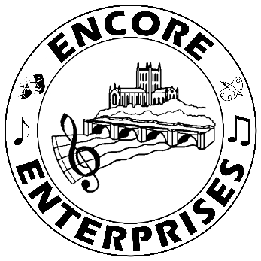
More fun weblinks to try at home
Summer Term - Week 4

On BBC Bitesize Daily there are many resources for music in key stage 1, 2 and 3 including the following topics:

• What is pulse and rhythm?
• What are melody and pitch?
• Improvising with the voice
• How to rap
• Using everyday objects to create music
• YolanDa’s Band Jam-Funky elephant

- https://www.bbc.co.uk/bitesize/articles/z6vpnrd

Rhinegold Education has some online lessons for music covering key stages 1, 2 and 3. They cover the topics:

• Music and space
• Body Percussion
• Storm music
• Crotchets and quavers

- http://blog.musicroom.com/

We’ve mentioned Musical Toad before but there are some brilliant new things on here for EYFS, KS1 and KS2

- https://www.musicaltoad.co.uk/

The National Youth Choir of Scotland has an amazing range of daily activities. Lots and lots of fun!!

- https://www.nycos.co.uk/daily-activities/?fbclid=IwAR2aKGqdLUs8TkRSH5E1HZTiQAk17XZ_Wun0_aueUVCjDbAlPi3G6v3VRvc

Music Mark have some brilliant links on here. There are resources for EYFS, primary age, secondary age and parents. Absolutely worthwhile checking some of these out.

- https://www.musicmark.org.uk/resources/home-learning-resources/

Classics for Kids games include: Learning musical terms, play note names, match the rhythm, compose your own music, open instruments in an orchestra, explore composer timeline and explore the composer map.

- https://www.classicsforkids.com/games.html

